**Amna Muhammad Essa**

**project: phonebook**

**DECRIPTION:**

**A message module used for storing information about some person like name and contact number.**

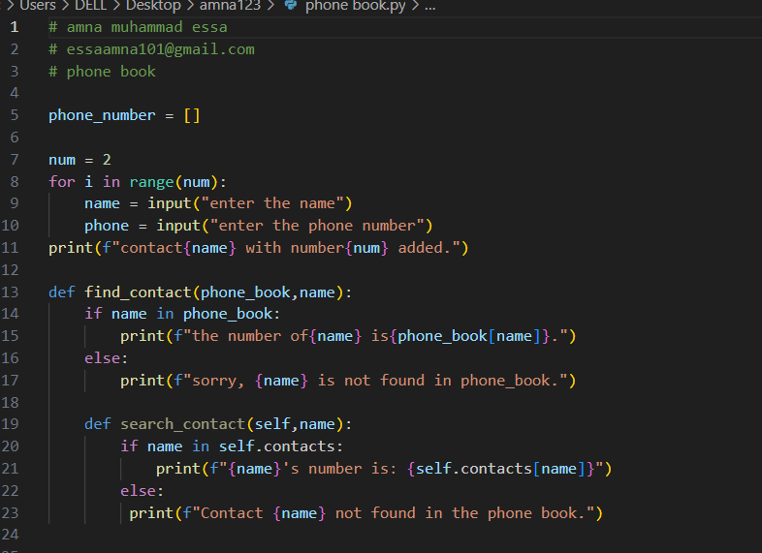am

